Chapter 2: Displaying and Describing Categorical Data

Part I: Frequency Table

**Titanic Example:**

1. **Create frequency table:**
2. Open the data file (Titanic_Redux.csv). In this file, there are two categorical variables which are Sex and Survive.

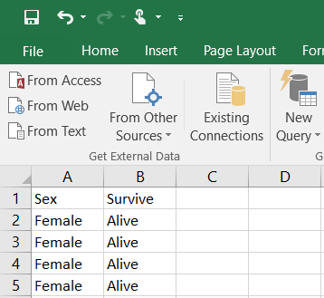

1. Click on the first cell and select the entire column by pressing **ctrl + shift + page down (pg dn - $↓$)**.

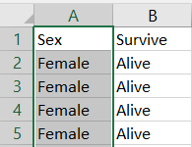

1. Click the **Data** tab, then click **Advanced**.

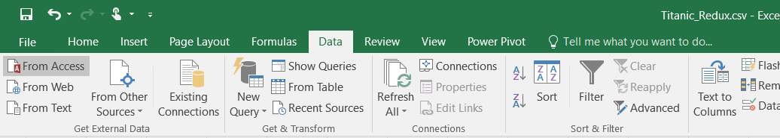

1. **Dialog box (Advanced Filter)** will open, and the range of data will show in **List range**.

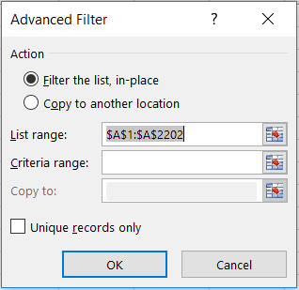

1. Select “**Copy to another location**” to create the frequency table in a new location. Click on **Copy to** and select the new location (in this example. We selected cell **H1**).

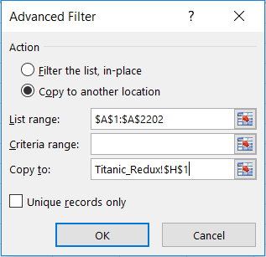

1. In **Criteria range**, select one of the categories in your variable (in this example, we selected **female**). Select **Unique records only**, and click **OK**.

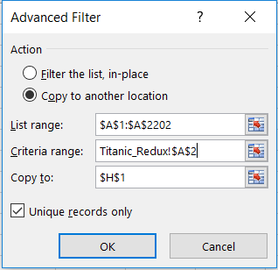

1. The first column of the frequency table will appear in the location that we selected.

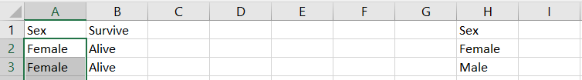

1. To create the second column, **counts**, of the frequency table, select a cell (I1), and write counts as a label. Select a cell (I2), and use **COUNTIF** function; we can write it as “=COUNTIF”.



or select it from **Formulas** tab $⟹$**More Functions $⟹$** **Statistical $⟹$** **COUNTIF**.

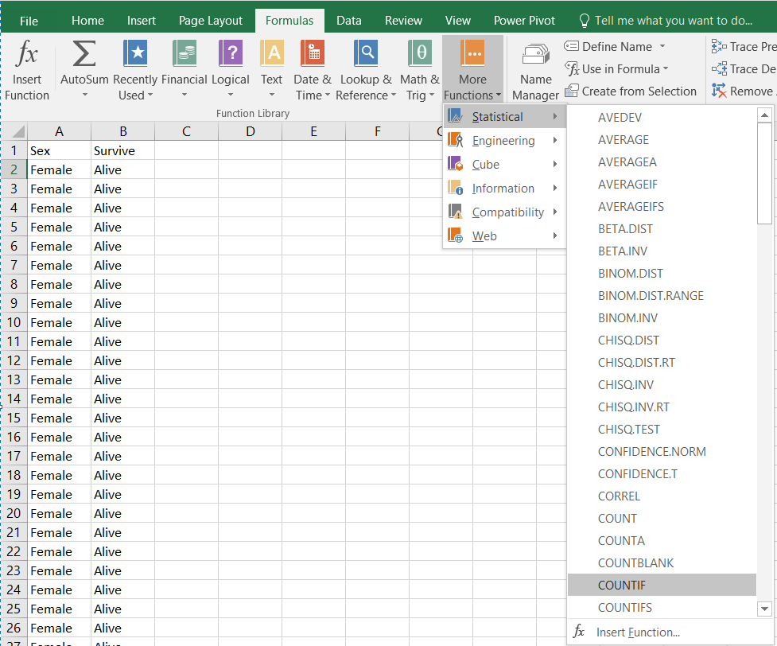

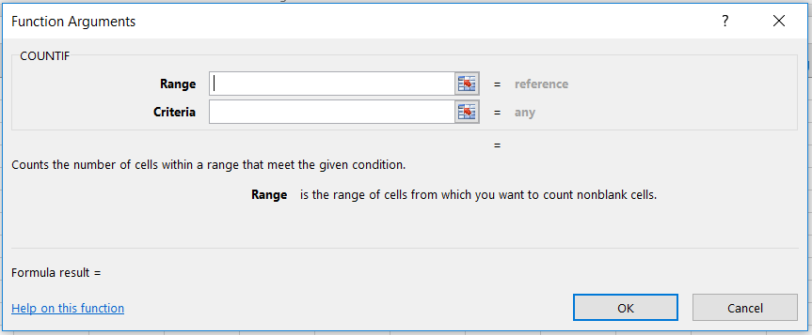

**range** : The range of cells to count (the range of the dataset).

**criteria** : The criteria that controls with cells should be counted (in this example, male or female).



Do so for the other categories. You can just copy and paste the previous cell

1. The frequency table is:

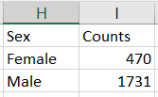

1. We can add the total to the frequency table by selecting a new cell ( I3 ), and select **Formulas** tab, click on **AutoSum** (**∑)** and press enter.

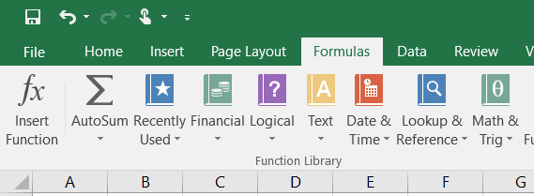

or you can use the **Sum** function by select the cell (I3) and write the function as “= SUM”, and select the cells that needs summing.





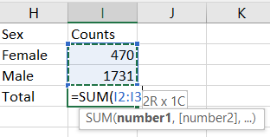

1. The frequency table is:

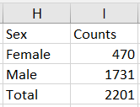

1. **Create relative frequency table:**
2. After creating a frequency table, add a new column (%) to count the percentage of each category.
3. Select a new cell (J2), write equal sign (=), then select the counts of the first category (I2) and divide it (/) by the total of the frequency table (I4).

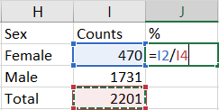

You can copy this formula for the other categories, write the dollar sign ($) between I and 4 (I$4) to lock the total cell (denominator).

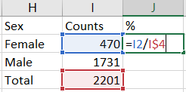

1. Copy and paste the formula to the other categories, and use the sum function for total.

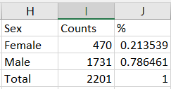

1. If we want the third column in percentage form, we can select the cells of this column and click on **%** bottom in **Home** tab.

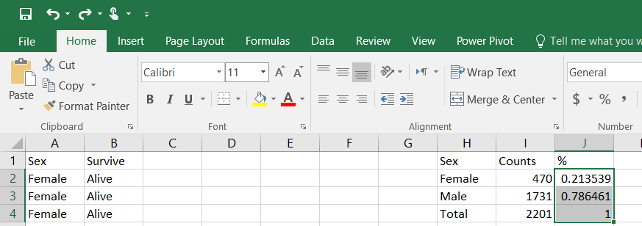

1. The relative frequency table is

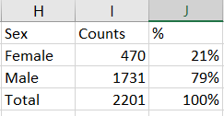

**Note:** make sure the total of the percentage column is 100% in percentage form or 1 in number form.

**Practice:**

Build a relative frequency table for the variable survive (second column) in the same data file (Titanic_Redux.csv).

